APRS Demo Instructions (<<INSERT VERSION/DATE>>)

1. Turn on both robots (Motoman and Fanuc)
2. On Fanuc:
   1. Set Auto/T1 switch on controller to Auto.
   2. Set the On/Off switch on Teach Pendant to off.
   3. Wait for display to fully come up.
   4. Adjust Feed override displayed in the top right corner of Teach Pendant to 100% using +% button near the center bottom.
   5. Twist the red estop button on the Teach Pendant to release it.
   6. Make sure the cart has one purple rectangular large gear parts tray, one blue square medium gear parts tray, and two brown pentagon shaped kit trays with slots for two medium gears and large gear in each tray. Put four orange medium gears and two large green gears in any appropriate slot. Make sure none of the trays are within three inches of the edge nearest the motorman. (see photo)
3. On Motoman:
   1. Move the Remote/Play/Teach switch with the key in it on the Teach Pendant to Remote.
   2. Twist the red estop button on the Teach Pendant to release it.
   3. Make sure the area of the conveyor between the motorman and the fanuc close to the fanuc side without touching the edge has two purple rectangular large gear parts trays, one orange square small gear parts tray, and two red pentagon kit trays with two small gear slots and two large gear slots each. Put four small yellow gears and four large green gears in any appropriate slot. (see photo)

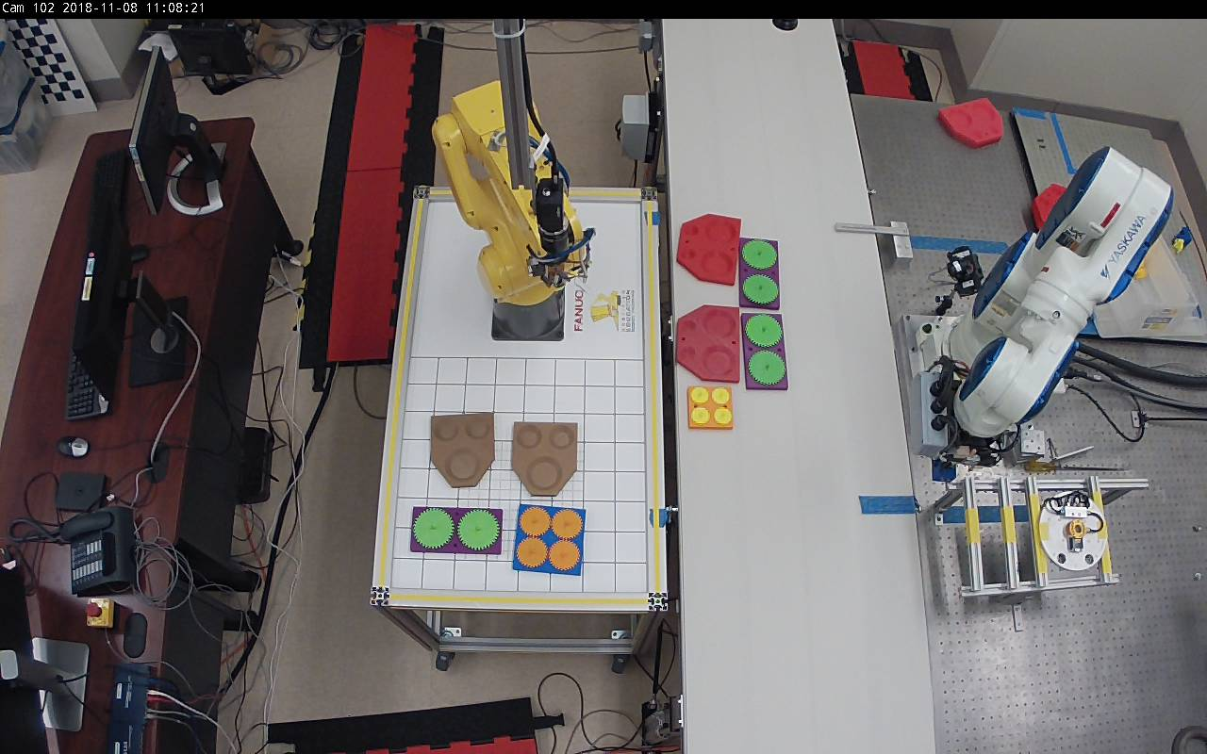

1. On the table with yellow dots used for teaching there should be trays and gears corresponding to all parts on both the fanuc cart and the table between the motorman and the fanuc. The brown kit trays for one large gear and two medium gears should point towards the wall between the lab and the hallway and the red kit trays with slots for two large and two small gears should point to the right side of the room as one enters. Avoid letting trays touch each other or the edge of the table.

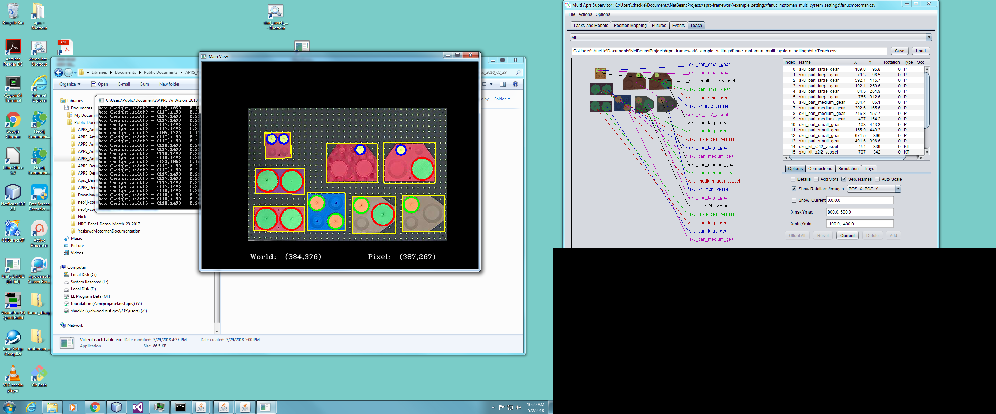

1. On the Dell PC named Optimus open the <<INSERT PATH TO DEMO FOLDER>> folder.
2. Double-click the run.bat file in that folder.
3. Wait while over about 30 seconds 3 small black text command windows and the “APRS External Processes” window pop up and then 3 grey graphical windows and one black graphical window with the tray display.

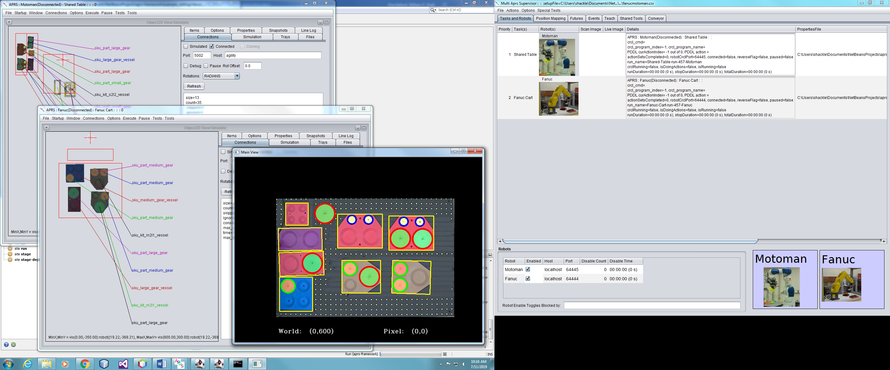

1. On the window titled “Multi Aprs Supervisor …”, select the teach tab. Verify that it is updating and the parts and trays correspond to their positions on the teach table. If it is showing all the trays click “Lock Trays” checkbox on the Connections tab on the right. This will means it will use the vision system from no one only for parts locations and assume trays stay at their current locations. This avoids problems caused by intermittently not seeing trays by the vision system.

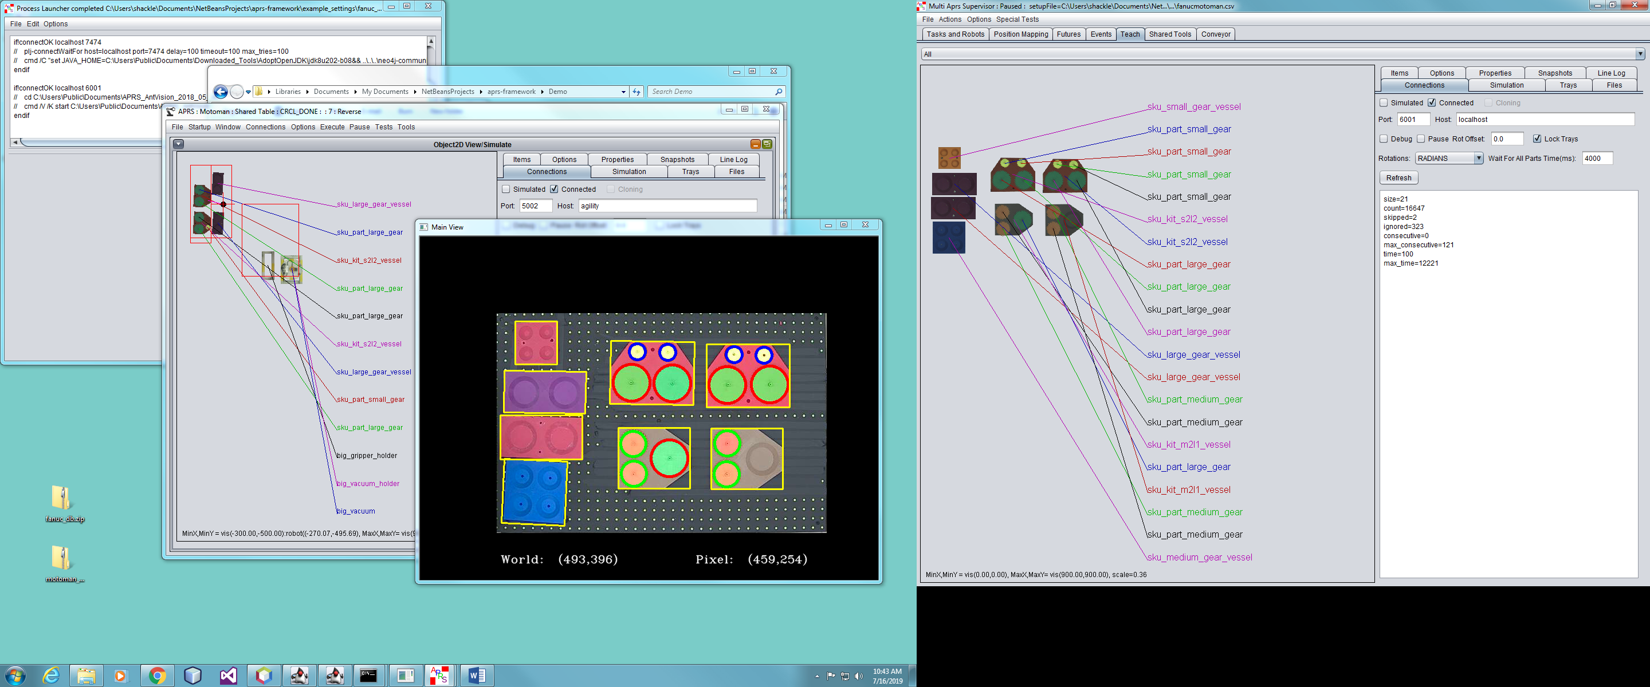

1. The window titled “APRS:Motoman …” should be displaying the part and tray positions for the items on the table near the motorman and the window titled “APRS:Fanuc …” should be displaying the part and tray positions for the items on the cart with the Fanuc. The positions should update slightly every second. On the window titled “Multi Aprs Supervisor …” on the Teach tab the positions of the parts on the table used for teaching configuration. The port and host each needs to connect to can be checked/set in the connection tab in the bottom right. If any window is not updating or the positions are not reasonable the vision system that is normally running on another PC may need to be restarted. Contact Brian Antonishek to have the vision system restarted. ( or check the document Vision_Startup_v_3.docx in  \\mission.el.nist.gov\Programs\mfg_robotics\agility_performance\APRS_Demo\ )
2. On the window titled “Multi Aprs Supervisor …” select Special Tests -> Start Continuous Scan and Run from the menu.
3. If the screen flashes Yellow and Red with “Not all Robots Enabled” (Depends on the state of Options -> Show Full Screen Messages checkbox in the menu.) or shows a small dialog like the following release both estops and try the previous step again.

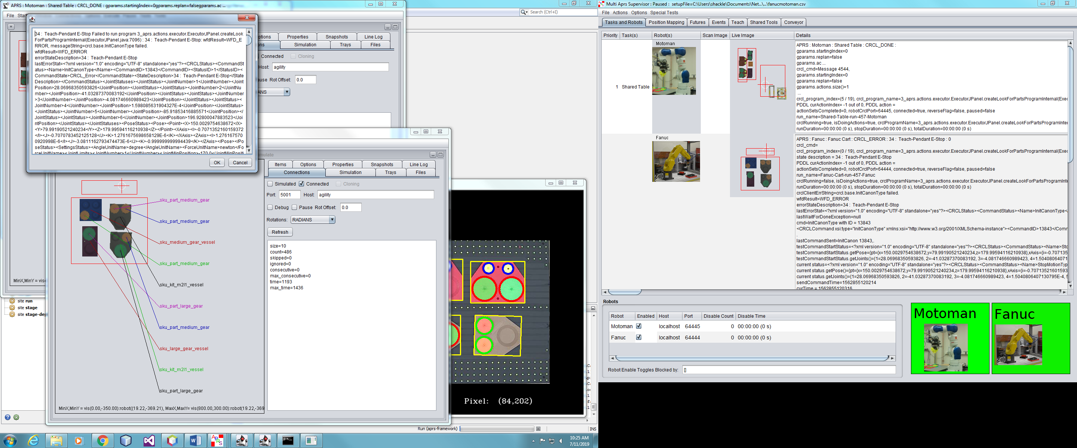

1. Both robots should move to their home positions (if they are not already there) and after a few seconds the screen should flash “Scans Complete” (Depends on the state of Options -> Show Full Screen Messages checkbox in the menu.) and/or show the following dialog.

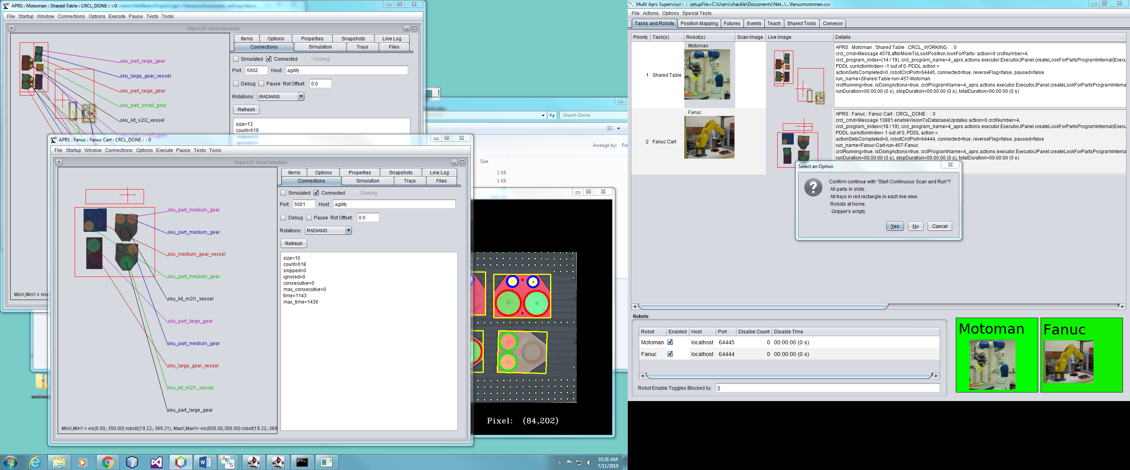

1. If all conditions in the dialog are true click the yes button to continue. (The following screen shot shows all parts and trays in the appropriate red rectangle(s) parts outside of these areas may not be reachable by one of the robots that needs to reach them.

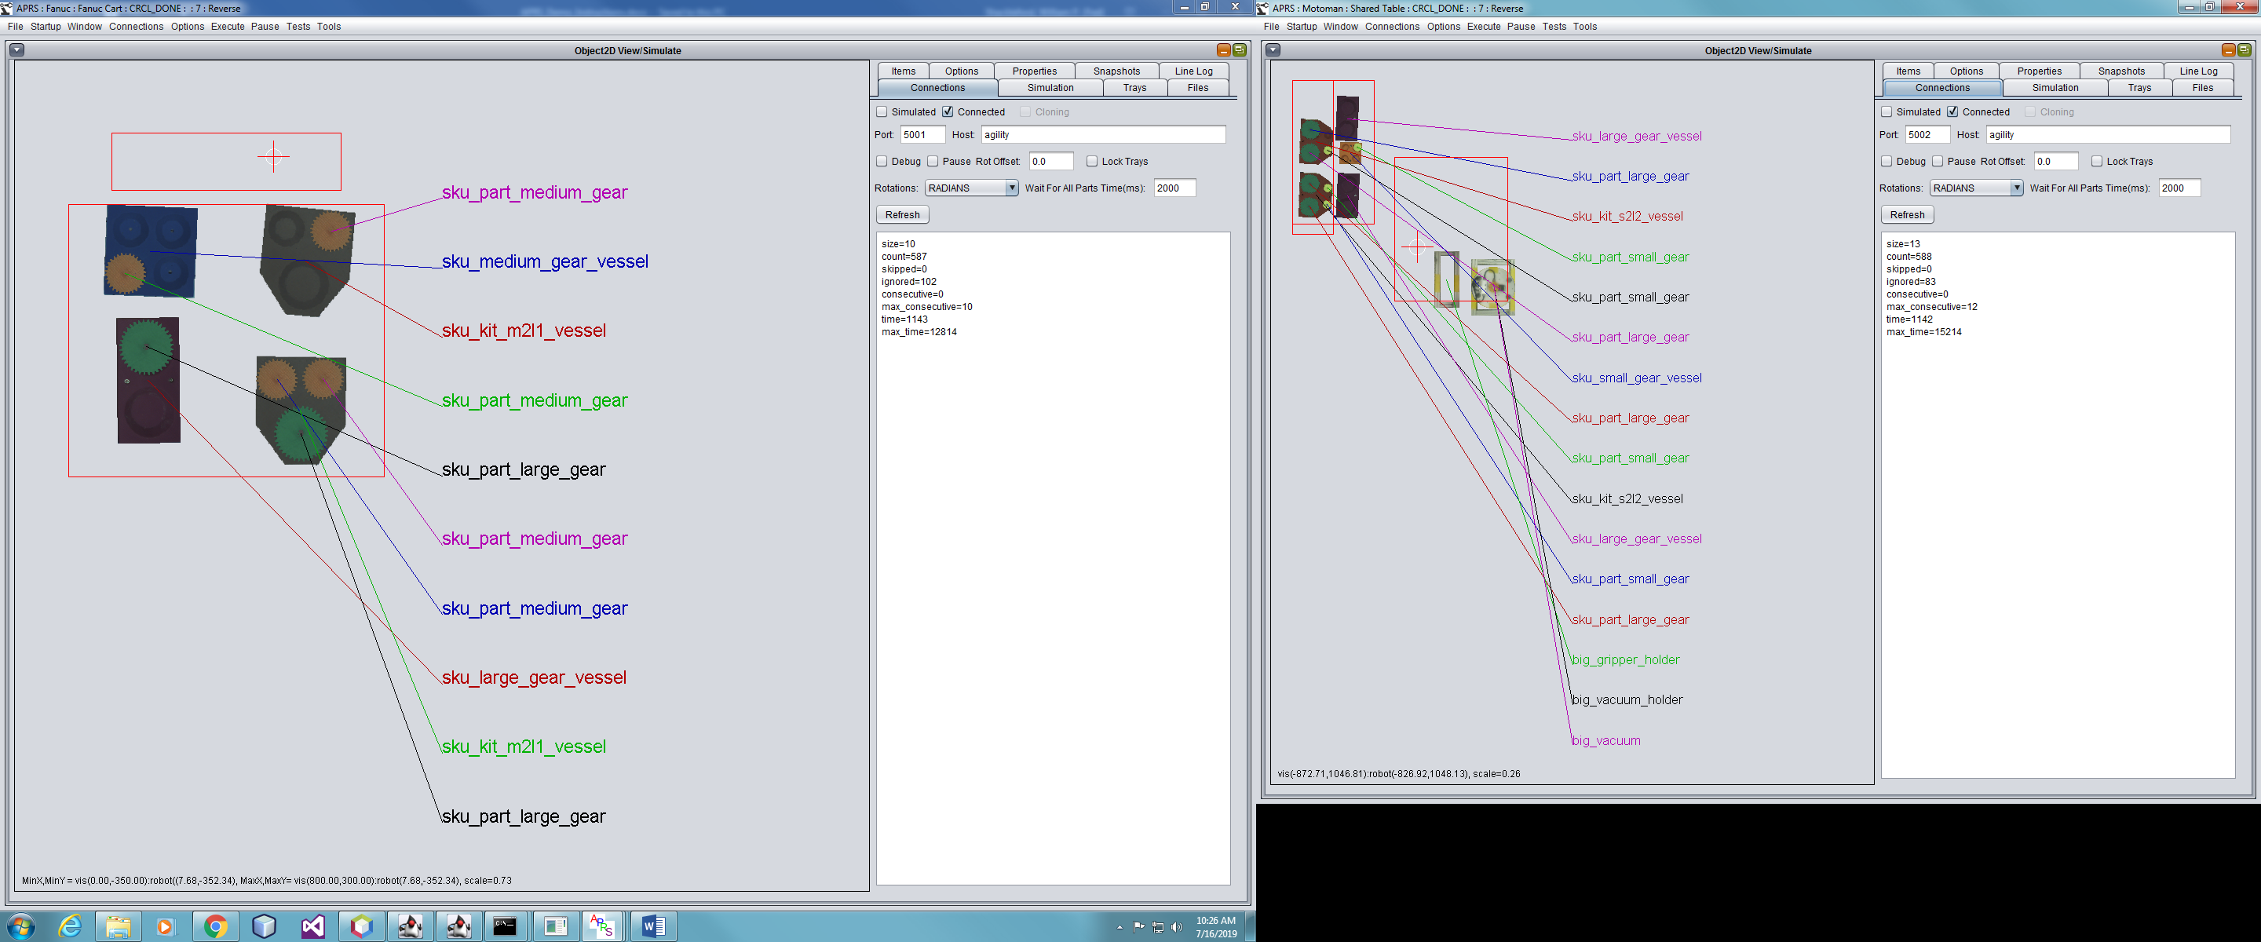



1. If all conditions in the dialog are true click the yes button to continue.
2. The system will repeatedly scan the table and command the robots to move gears to match the configuration on the table.
3. Move gears on the table to observe the robots following the changes.
4. Select the “Tasks and Robots” tab on the “Multi Aprs Supervisor” window.
5. On the window titled “Multi Aprs Supervisor …” select Special Tests -> “ Start Scan All then Continous Demo Rev First” from the menu.
6. After a few seconds the following dialog should appear. 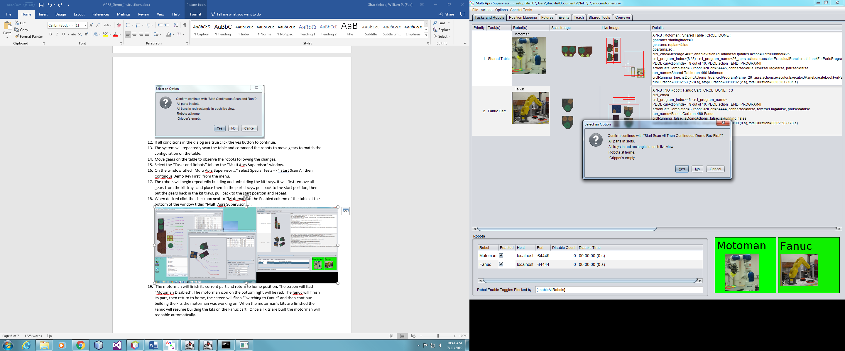
7. If all conditions in the dialog are true click the yes button to continue.
8. The robots will begin repeatedly building and unbuilding the kit trays. It will first remove all gears from the kit trays and place them in the parts trays, pull back to the start position, then put the gears back in the kit trays, pull back to the start position and repeat.
9. When desired click the checkbox next to “Motoman” in the Enabled column of the table at the bottom of the window titled “Multi Aprs Supervisor …” with the “Tasks and Robots” tab selected.



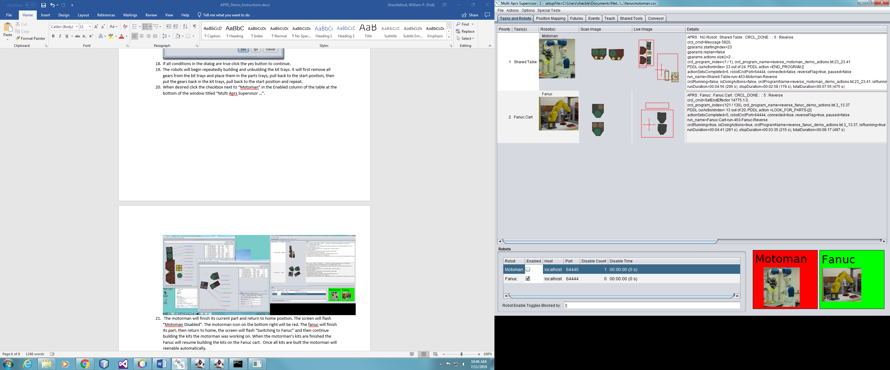

1. The motorman will finish its current part and return to home position. The screen will flash “Motoman Disabled”. The motorman icon on the bottom right will be red. The fanuc will finish its part, then return to home, the screen will flash “Switching to Fanuc” and then continue building the kits the motorman was working on. When the motorman’s kits are finished the Fanuc will resume building the kits on the Fanuc cart. Once all kits are built the motorman will reenable automatically.
2. Wait until the Fanuc is moving parts to the kit trays. On the window titled titled “APRS:Fanuc …” check the menu option checkbox Test -> Force Fake Take. This will cause the grippers to fail to close the next time that robot tries to take a part. After it fails to pick up a part uncheck the checkbox. It will continue building the kit afterward. When it is finished that part will be missing from the kit. The robot will return to home position, see that the part is missing and pickup and place that part to complete the kit.
3. When the demo is finished select Actions -> Safe Abort All from the menu on the window titled “Multi Aprs Supervisor …”. Both robots will finish one part, returned to home position and the screen will flash “Safe Abort Complete”.
4. Press the estop buttons on both teach pendants.
5. Close all the windows that were opened including the 3 small black command windows. The black graphical window that shows the teach table parts will reopen if you close it directly but will close after one of the black command windows closes.
6. Turn off both robots.